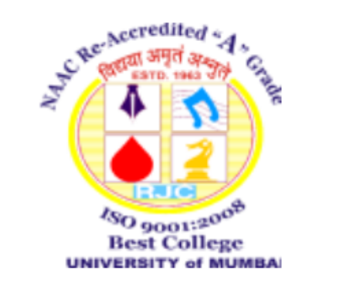

**RAMNIRANJAN JHUNJHUNWALA COLLEGE OF SCIENCE , COMMERCE & ARTS**

*(Affiliated to University of Mumbai)*

Opp. Ghatkopar Railway Station, Ghatkopar (W), Mumbai - 400086

**(Session: Dec 2022– Mar 2023)**

**Mini Project Final Report Contents**

***The organization of the report should be as follows:***

* Abstract or Synopsis not exceeding 100 words
* Table of Contents
* Introduction (scope of the work and its importance)
* Design/Implementation
* Testing/Result and Analysis
* Conclusions & future enhancements
* References- in standard IEEE format.

HOD

IT